**Spring Data JPA - Quick Example**

1. Country.java

package com.cognizant.orm_learn.model;  
  
import jakarta.persistence.Column;  
import jakarta.persistence.Entity;  
import jakarta.persistence.Id;  
import jakarta.persistence.Table;  
  
@Entity  
@Table(name = "country")  
public class Country {  
  
 @Id  
 @Column(name = "code")  
 private String code;  
  
 @Column(name = "name")  
 private String name;  
  
 public String getCode() { return code; }  
 public void setCode(String code) { this.code = code; }  
  
 public String getName() { return name; }  
 public void setName(String name) { this.name = name; }  
  
 @Override  
 public String toString() {  
 return "Country [code=" + code + ", name=" + name + "]";  
 }  
}

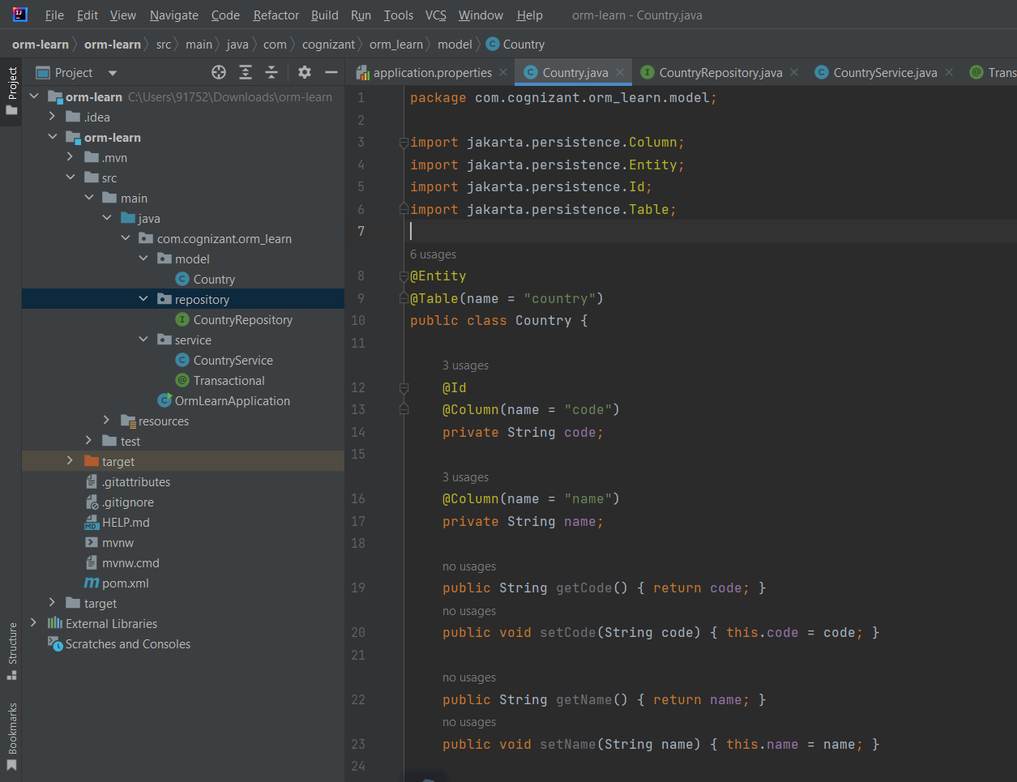

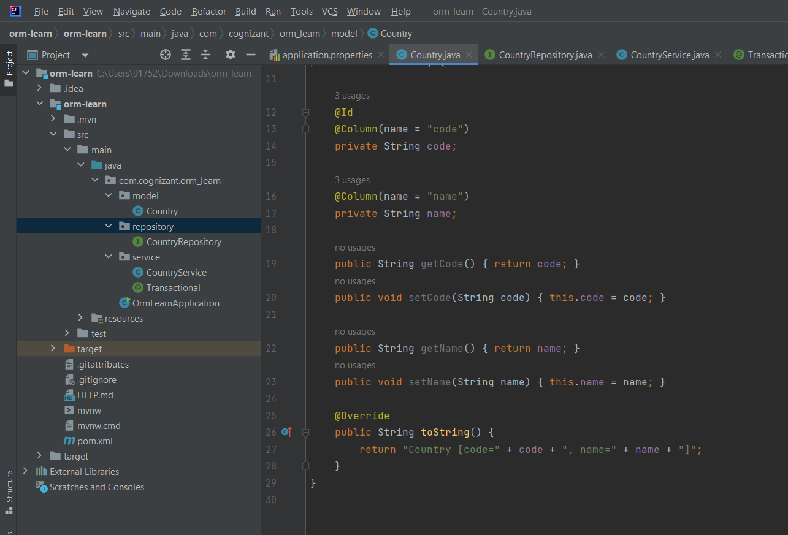

1. CountryRepository.java
2. package com.cognizant.orm_learn.repository;  
     
   import com.cognizant.orm_learn.model.Country;  
   import org.springframework.data.jpa.repository.JpaRepository;  
   import org.springframework.stereotype.Repository;  
     
   @Repository  
   public interface CountryRepository extends JpaRepository<Country, String> {}
3. CountryService.java

package com.cognizant.orm_learn.service;  
  
import com.cognizant.orm_learn.model.Country;  
import com.cognizant.orm_learn.repository.CountryRepository;  
import org.springframework.beans.factory.annotation.Autowired;  
import org.springframework.stereotype.Service;  
  
import java.util.List;  
  
@Service  
public class CountryService {  
  
 @Autowired  
 private CountryRepository countryRepository;  
  
 @Transactional  
 public List<Country> getAllCountries() {  
 return countryRepository.findAll();  
 }  
}

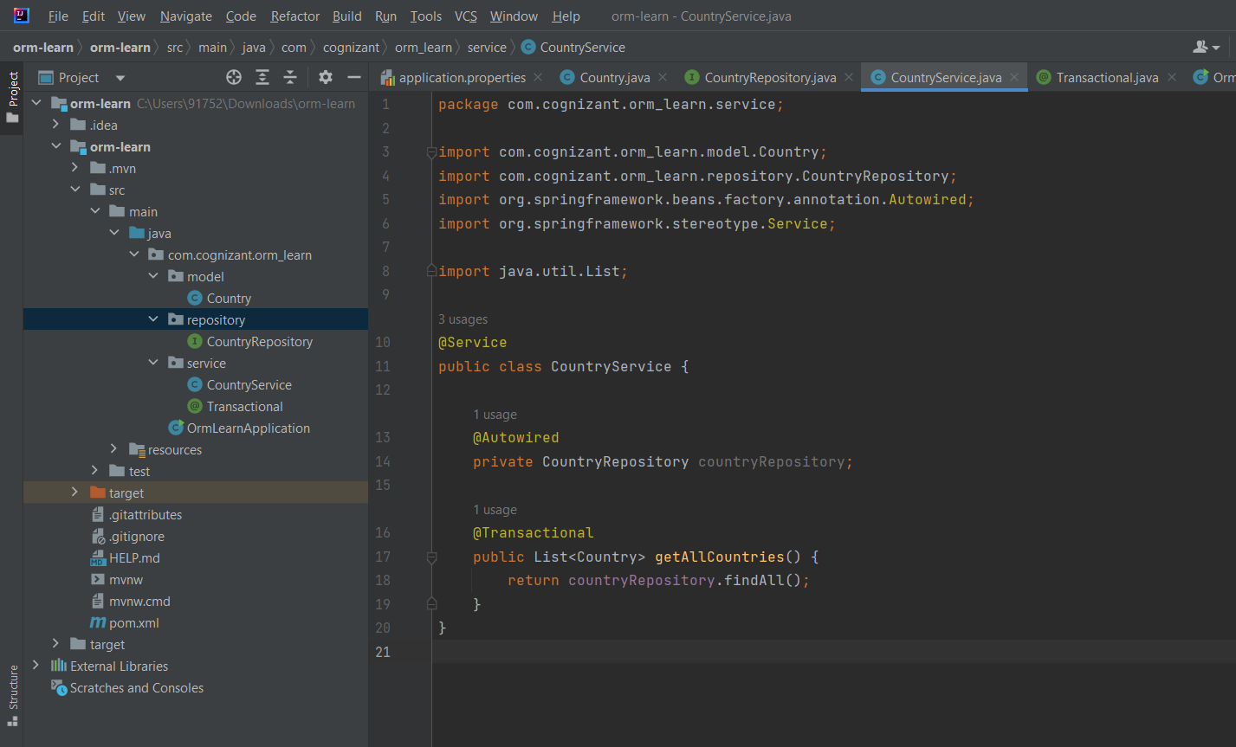

1. OrmLearnApplication.java
2. package com.cognizant.orm_learn;  
     
   import com.cognizant.orm_learn.model.Country;  
   import com.cognizant.orm_learn.service.CountryService;  
   import org.slf4j.Logger;  
   import org.slf4j.LoggerFactory;  
   import org.springframework.boot.SpringApplication;  
   import org.springframework.boot.autoconfigure.SpringBootApplication;  
   import org.springframework.context.ApplicationContext;  
     
   import java.util.List;  
     
   @SpringBootApplication  
   public class OrmLearnApplication {  
     
    private static final Logger *LOGGER* = LoggerFactory.*getLogger*(OrmLearnApplication.class);  
    private static CountryService *countryService*;  
     
    public static void main(String[] args) {  
    ApplicationContext context = SpringApplication.*run*(OrmLearnApplication.class, args);  
    *LOGGER*.info("Inside main");  
     
    *countryService* = context.getBean(CountryService.class);  
    *testGetAllCountries*();  
    }  
     
    private static void testGetAllCountries() {  
    *LOGGER*.info("Start");  
    List<Country> countries = *countryService*.getAllCountries();  
    *LOGGER*.debug("countries={}", countries);  
    *LOGGER*.info("End");  
    }  
   }

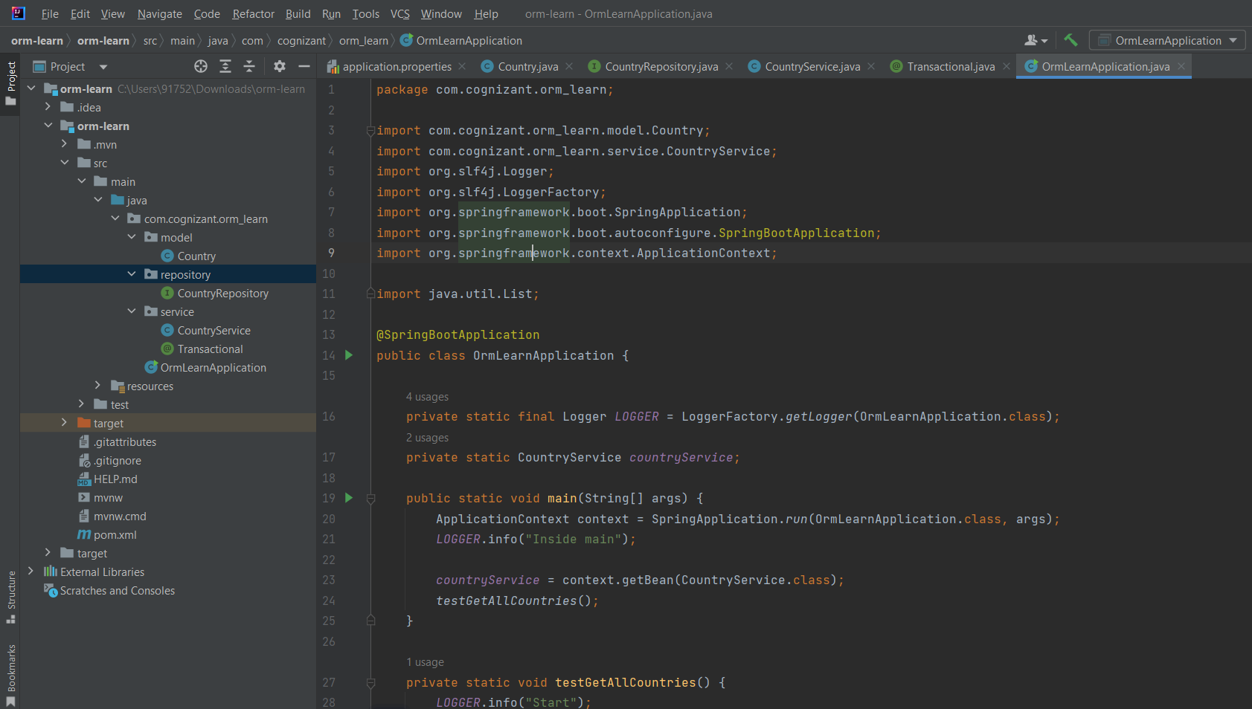

1. application.properties
2. spring.application.name=orm-learn  
   # Logging Configuration  
   logging.level.org.springframework=info  
   logging.level.com.cognizant=debug  
   logging.level.org.hibernate.SQL=trace  
   logging.level.org.hibernate.type.descriptor.sql=trace  
     
   # Log pattern  
   logging.pattern.console=%d{dd-MM-yy} %d{HH:mm:ss.SSS} %-20.20thread %5p %-25.25logger{25} %25M %4L %m%n  
     
   # Database Configuration  
   spring.datasource.driver-class-name=com.mysql.cj.jdbc.Driver  
   spring.datasource.url=jdbc:mysql://localhost:3306/ormlearn  
   spring.datasource.username=root  
   spring.datasource.password=root  
     
   # Hibernate Configuration  
   spring.jpa.hibernate.ddl-auto=validate  
   spring.jpa.properties.hibernate.dialect=org.hibernate.dialect.MySQL5Dialect

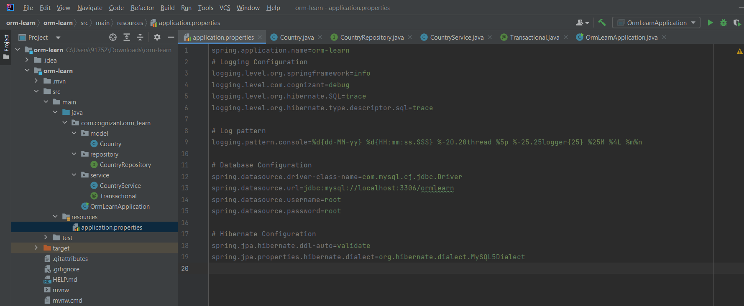

Project structure

